Sea Shanty – Maxi 1000
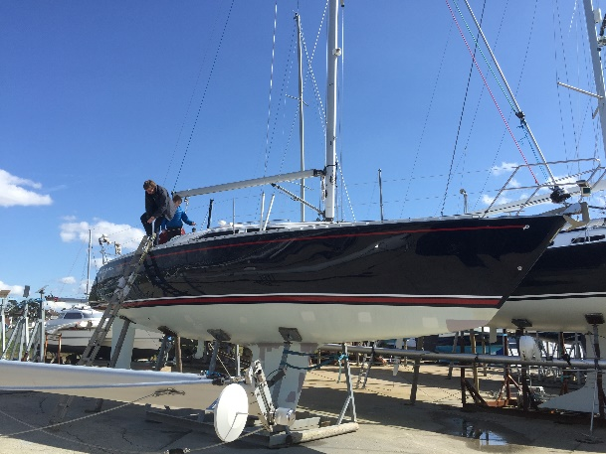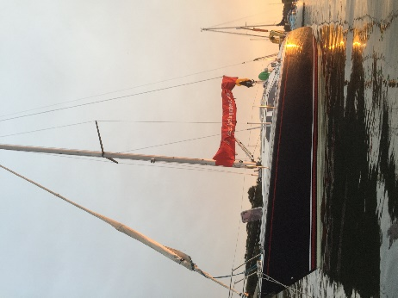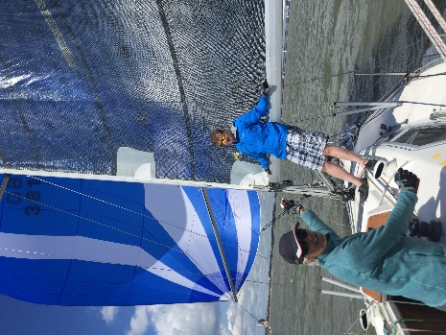

We bought Sea Shanty in December 2014 because we wanted a boat we could both cruise and club race with family and friends. Sea Shanty is fast, easy to sail, very stable and handles rough seas really well. She is comfortable for 4 people to cruise and has 6 berths. We regularly did a trip to Cowes for Cowes week and have cruised in France and Holland. She is well equipped for passage sailing and club racing but just as delightful at anchor and swimming from the bathing platform.

Sea Shanty has required quite a bit of modernising and investing. Local yacht care service has been provided by Peter Creasy working on a retainer for past 5 years. Peter has overseen all the maintenance, improvement, and repairs. Peter would gladly talk to any potential purchaser about the high standard of work he has done. The engine has always been winterised and serviced for each season. Invoice records are included for these:
2015 Sea Shanty was equipped with new ropes, guard rails, spinnaker pole, safety equipment and new race sails in preparation for club racing
2016 – Overheating issue with engine was identified as wrong size propeller, after much attention to the engine, including gear box and sail drive strip down and replacement of diaphragm. With new folding propeller the engine has been faultless ever since.
2017 – new x2 Raymarine display panels were added above the hatchway, new VHF and antenna, nav lights. Also a vertical track on the mast for the spinnaker pole
2018 – teak work in the cockpit and revarnishing the interior where there had been significant wear. Galley floor was covered with Treadmaster due to the slippery nature of the floor panels and an accident at sea with the cooker. A new Garmin 300 chart plotter and AIS system was added.
2019 – The Hull was refurbished by blasting back and recoating. There was a repair to the fuel tank due to a slow leak. Damaged cooker/oven replaced with new.
2020 – There are a small number of items being attended to by Foxs but no major work required.
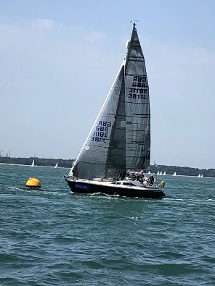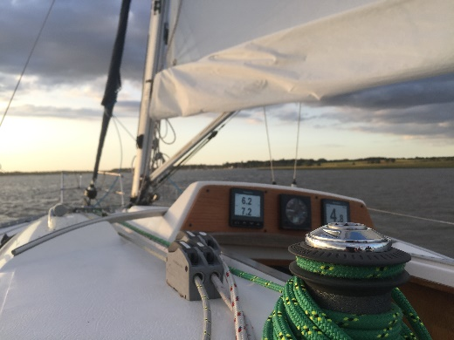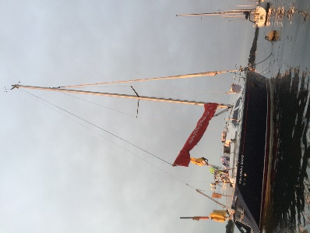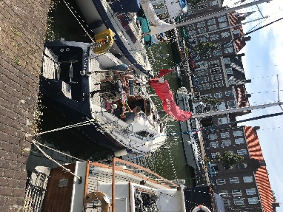

Documents available:
- MCA ships registry
- Radio licence
- Insurance 2021
- Gas safety report 8/19 new cooker
- Survey reports 2014 & 2010
- Gas compliance report 2015 & 2019
- Sales agreement 2014
- Bill of sale 1999, 2010, 2014
- Builders Certificate
- VAT invoice
- SSR Certificate
- Invoices 2015 -2020 – numerous filed by year

Sails:
Cruising Sails:
- Aran/Rockall fully battened main (2013)
- Furling Jib
- Furling Genoa
- Self-tacking jib system available (currently removed from deck)
- Gennaker with self-stuffer
Racing Sails
- Doyle DLP Technora Black Mainsail 33m2 (P=12.0m,E=4.2m), 2015
- Doyle DLP Technora Black J3 18.5m2 (LL=10.8, LP=3.59), 2015, now with furling battens
- Doyle All Purpose Symmetric Spinnaker 65m2 (LL=11.1, SMG=101%), 2015
- OneSail (Parker & Kay) #1 Genoa Vantage1 26.6m2 (LL=11, LP=5), 2018
- OneSail (Parker & Kay) #2 Genoa Vantage1, 2020
- OneSail reconditioning of Main and J3, 2020
- IRC 2018 TCC 0.927

